InsightFlow Decision Assistant
1. Present Platform
InsightFlow is a growing company that helps its leadership team make business decisions using information collected from different business functions.
The company is currently trialing an AI Decision Assistant that prepares decision briefs for leadership.
2. Current Scenario
- AI struggles to understand and use the right information - Leadership requests can be unclear, so the AI may misunderstand the intent, focus on the wrong information, and use older information even when newer information is available.
- AI must work across multiple sources and responsibilities - Relevant information exists in different business systems, while the workflow requires different AI capabilities for collecting information, analyzing it, and preparing the final decision brief.
- AI recommendations cannot be blindly trusted - The AI may present assumptions as confirmed facts, and its recommendations can influence important leadership decisions, so human review is required before action.
Problems
Problem 1 - Unclear User Intent
- Unclear request: Leadership's request may be ambiguous, making it difficult for the AI to understand the exact goal.
- Wrong information focus: The AI may interpret the request incorrectly and focus on information that is not relevant to the decision.
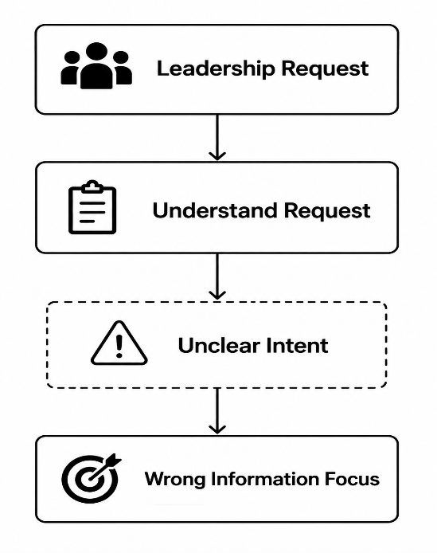
Problem 2 - Multiple AI Responsibilities
- Different responsibilities: The workflow needs separate AI capabilities for collecting information, analyzing it, and preparing the final decision brief.

- Need for specialization: A single AI capability may not handle all these responsibilities effectively, making the workflow harder to manage and control.
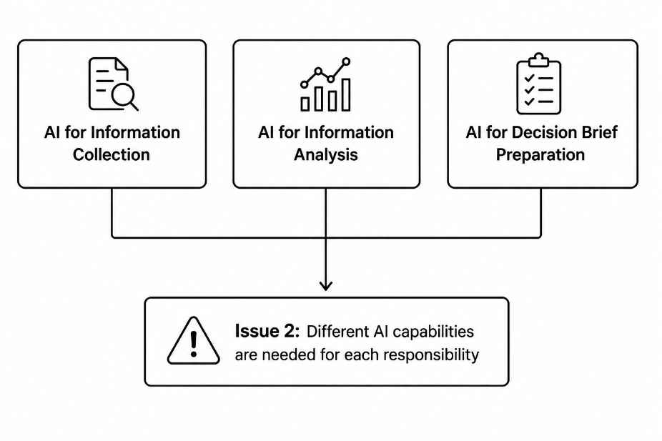
Problem 3 - Multiple Information Sources
- Multiple business systems: Relevant information is stored across different business systems.
- Information must be combined: The AI needs to bring information from these separate systems together before it can analyze the complete picture.

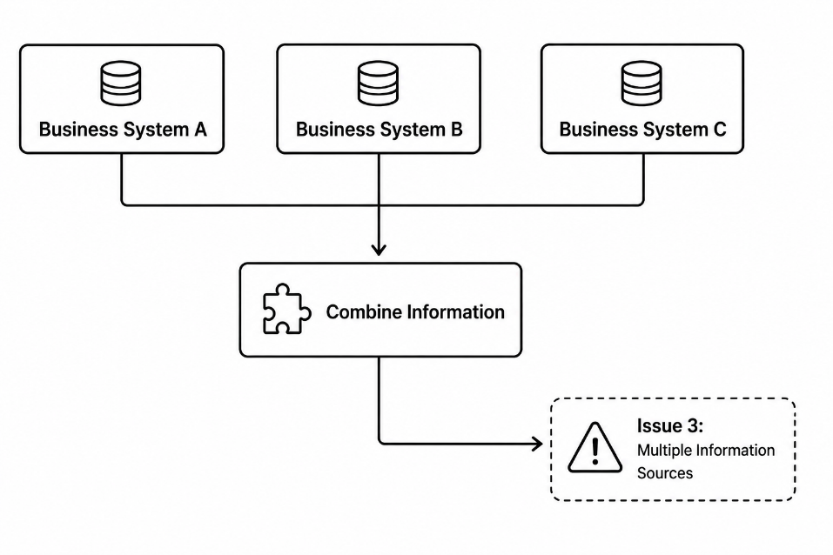

Problem 4 - Outdated Information
- Older information: Newer information may already be available, but the AI may still use older information.
- Unreliable results: Using outdated information can lead to incorrect analysis and unreliable decision briefs.
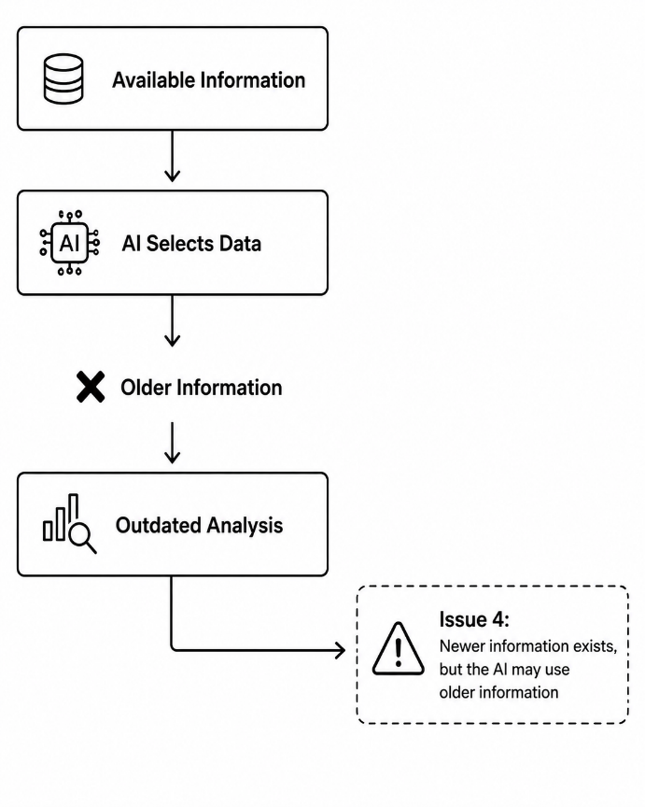
Problem 5 - Fact vs. Assumption
- Unverified assumptions: The AI may make assumptions or interpretations while analyzing the available information.
- Unreliable decisions: The AI may present those assumptions as confirmed facts, which can lead to unreliable decision-making.
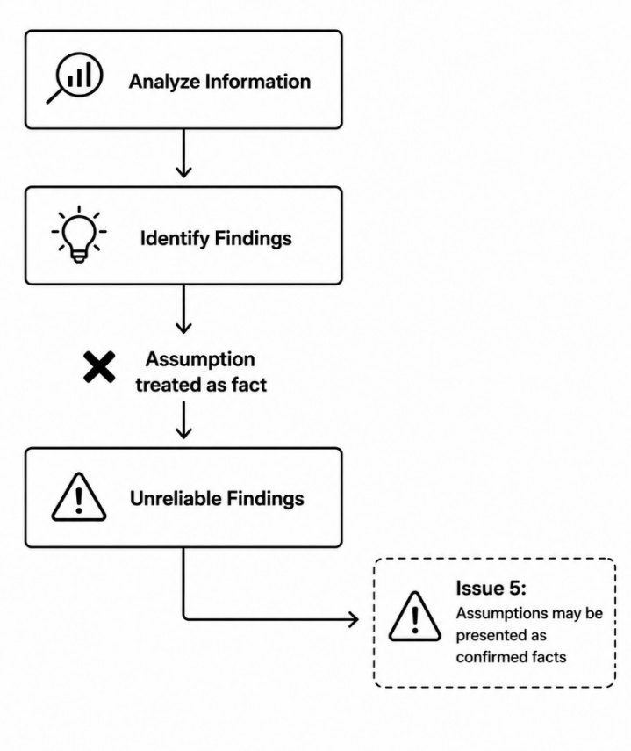
Problem 6 - Need for Human Review
- Important decisions: AI-generated recommendations can influence important leadership decisions and should not be acted on blindly.
- Human approval: A human should review and approve the AI recommendation before any important decision or action is taken.
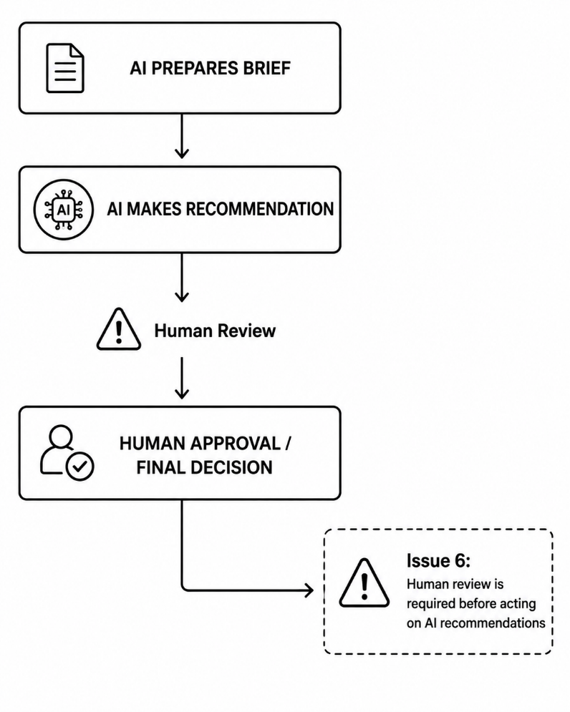

Current Architecture:
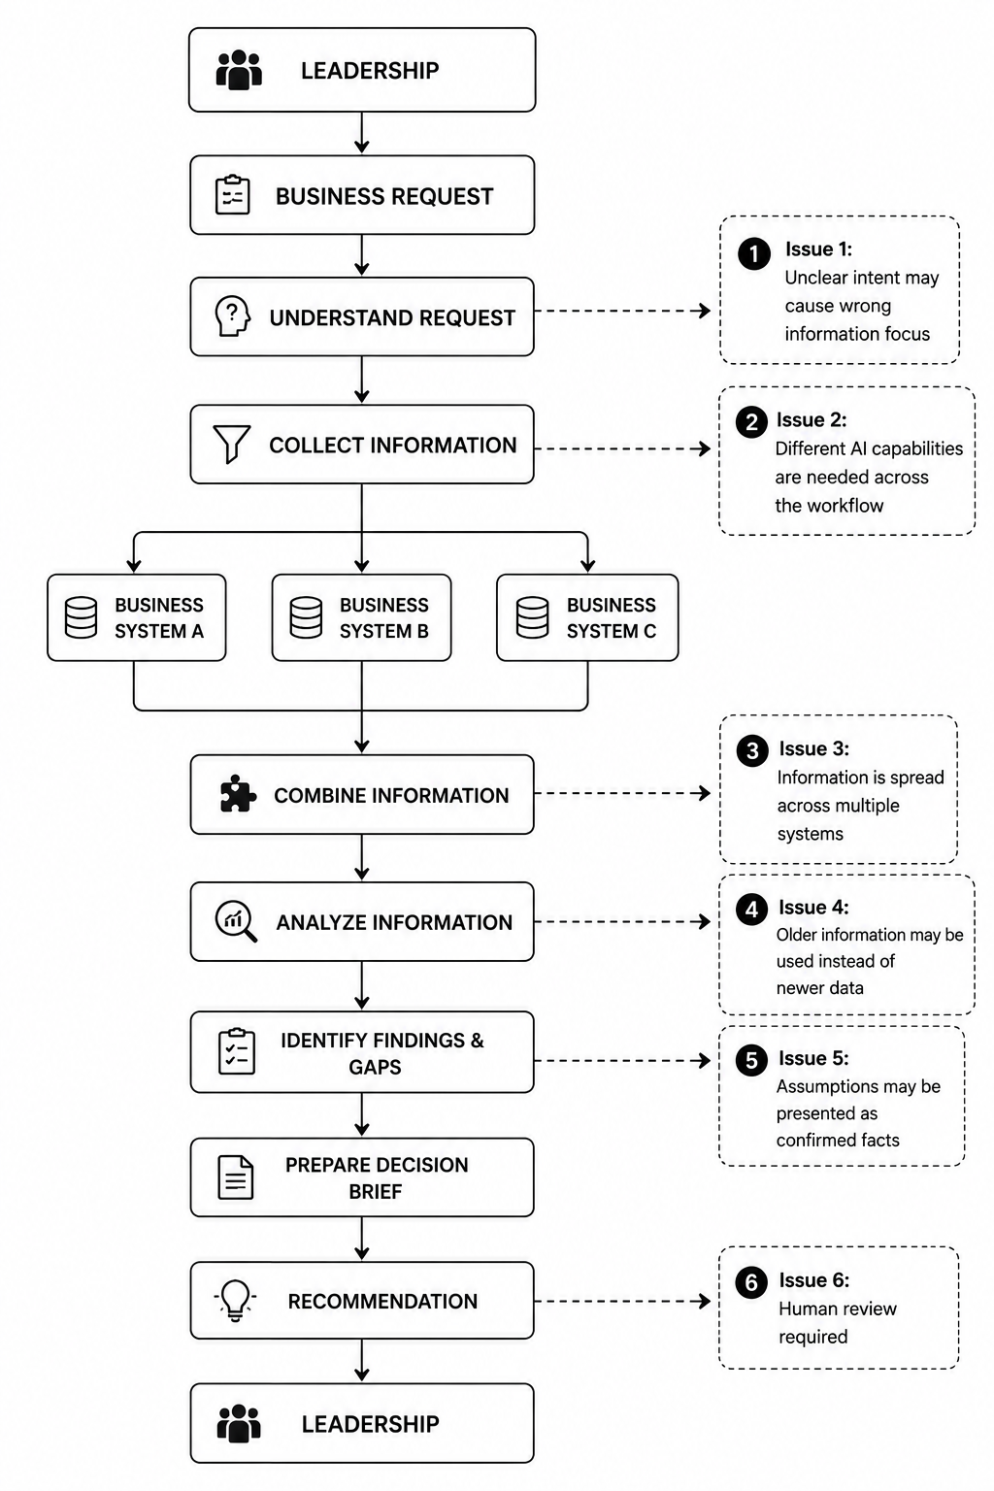

Solutions:
Problem 1 - Unclear User Intent
Solution: Intent & Goal Understanding
- Clarify the leadership request: Identify the exact goal and required information before the AI starts collecting or analyzing data.
- Ask for clarification: When the request is unclear or incomplete, ask the user for more details instead of making assumptions.
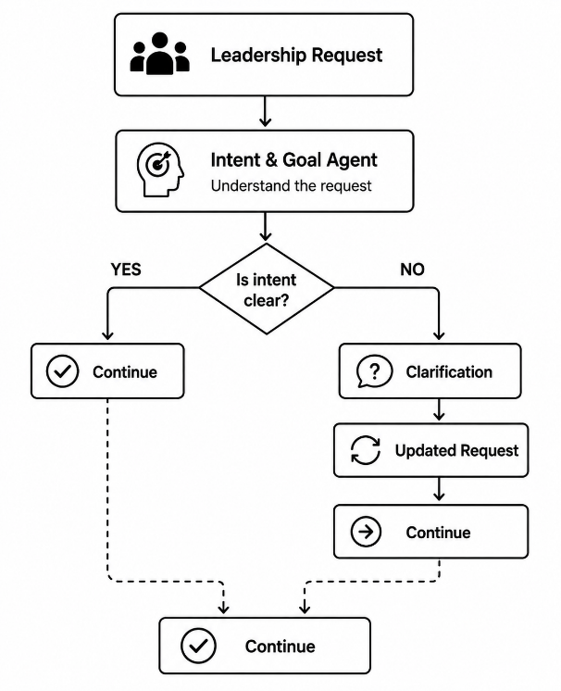
Problem 2 - Multiple AI Responsibilities
Solution: Specialized AI Agents
- Separate responsibilities: Use dedicated AI agents for information collection, information analysis, and decision-brief preparation.
- Coordinate the workflow: Connect the specialized agents so each agent completes its responsibility and passes the result to the next stage.
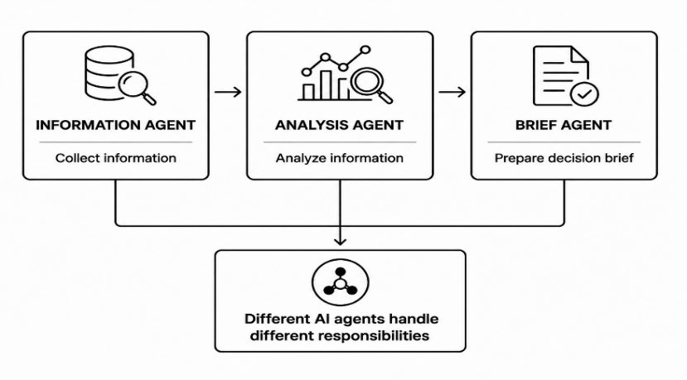
Problem 3 - Multiple Information Sources
Solution: Centralized Information Aggregation
- Connect all relevant business systems: Allow the AI to collect required information from multiple business sources.
- Create a unified view: Combine the collected information into one complete view before the Analysis Agent processes it.
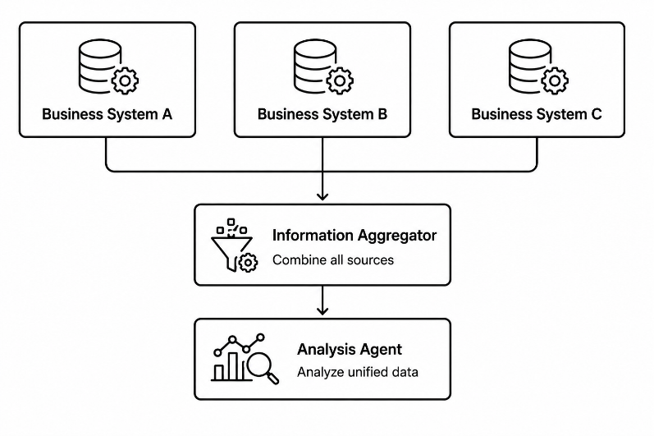
Problem 4 - Fact vs. Assumption
Solution: Fact Validation & Grounding
- Separate facts from assumptions: Clearly distinguish confirmed facts from AI-generated assumptions or interpretations before including them in the decision brief.
- Validate important findings: Check key findings against reliable source information and clearly flag anything uncertain instead of presenting it as a confirmed fact.
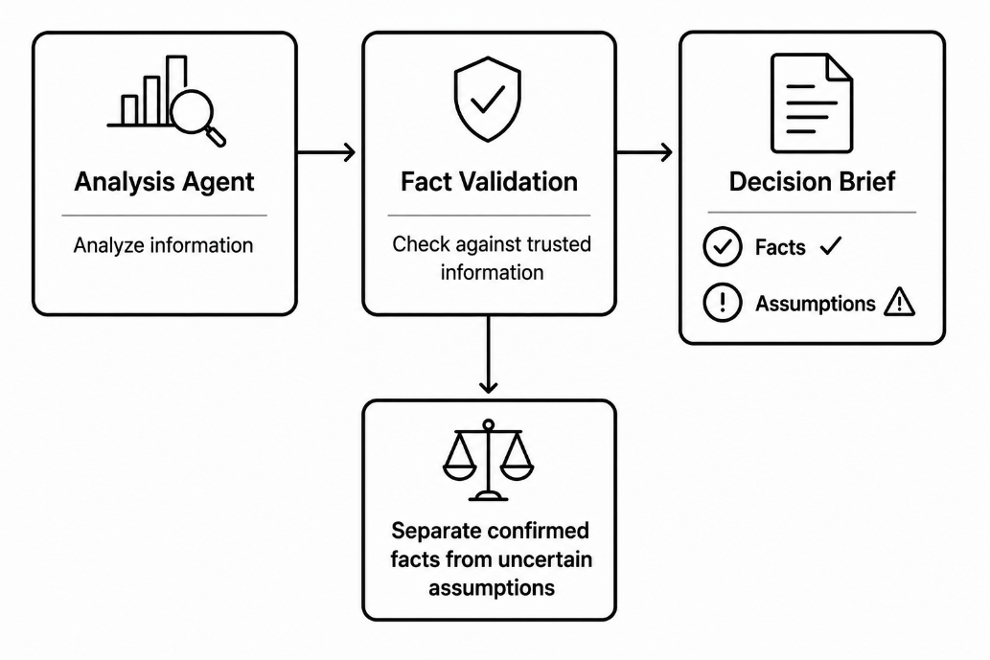

Problem 5 - Outdated Information
Solution: Information Recency & Validation
- Prioritize the latest information: Use the most recent available information from the business systems when collecting data.
- Validate before analysis: Check the information's date and relevance before using it for analysis and the final decision brief.
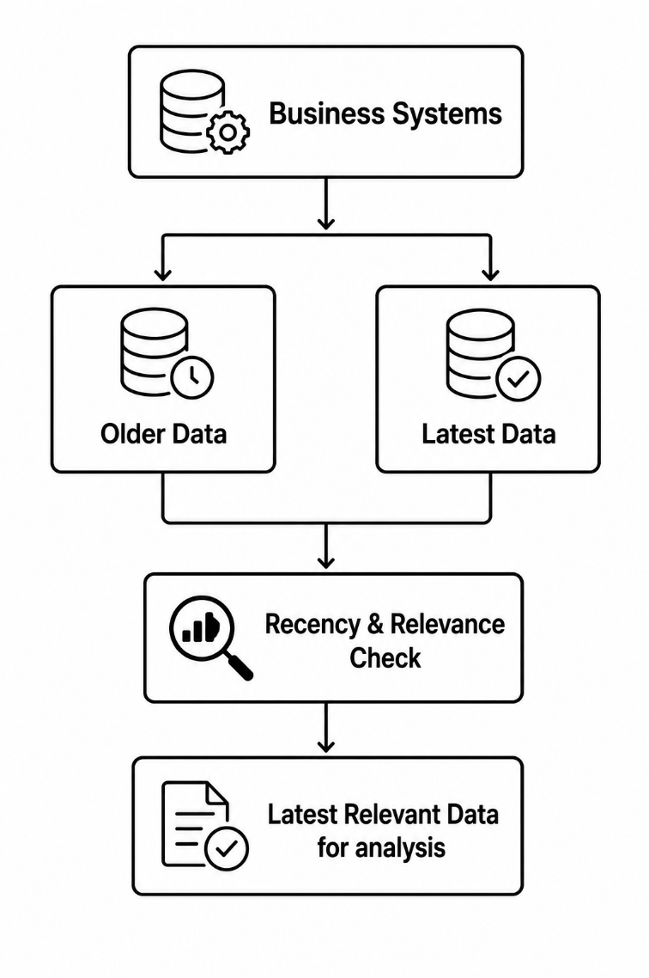

Problem 6 - Need for Human Review
Solution: Human-in-the-Loop (HITL)
- Route AI recommendations to human review: Send AI-generated recommendations to a human before any important leadership decision or action is taken.
- Allow human final control: The reviewer can verify, approve, reject, or correct the AI recommendation before the final decision.
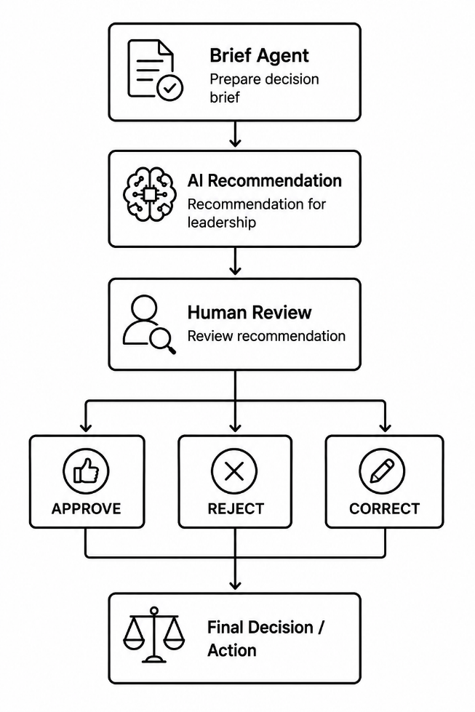

Proposed Architecture:
